INOC ANALYSIS REPORT

INOC REPORT

The incident report data file contains 30 columns and 1479 rows.
The columns represent different attributes of each incident, such as report date, customer, ticket, severity, reason and repair details, availability percentage, and more, total 30 distinct data fields.
The number of rows, 1479, represents individual incident records logged for the report period.
This structure provides a detailed tabular view for tracking and analyzing network incidents comprehensively with 30 different data aspects per 1479 incident events.
Report Period and Customer Impact:
- The data spans the entire month of June 2024.
- There were 37 unique customers affected across the incidents.
- A total of 367 support tickets were generated, indicating multiple issues per customer in some cases.
Complaint Types:
- The majority of incidents were classified as "Flapped" (1359 instances), indicating intermittent disruptions or link instability.
- "Down" incidents, which imply complete outages, were recorded 251 times.
- A small number of "Flapping" incidents (2) were noted, which often refer to repeated link status changes over a short period.
Severity Levels:
- Incidents were primarily of "High" severity (1119 cases), which likely demanded immediate attention due to impact on service quality.
- "Critical" severity was significant at 330 cases, representing the most severe interruptions.
- Lower severity incidents numbered 160, indicating less urgent but still notable issues.
Top Incident Reasons:
- The leading cause was traffic impact related to problems in SEG-2 affecting all FP (Forwarding Plane) segments (243 incidents).
- Switching hits in segments SEG-3 and SEG-2 caused connectivity problems and link flapping in multiple cases (total over 300 incidents when combining related reasons).
- Planned maintenance and relocation work on EIG cables caused downtime for 41 incidents, showing that scheduled activities also contributed to service impact.

key column in the incident report data:
- Report Date: The date on which the incident report was logged.
- Customer: The name of the customer affected by the incident.
- Ticket: Unique identifier for the incident or support ticket.
- Org. Group: The organizational group responsible for handling the incident.
- Create Date: Date and time when the incident ticket was created.
- Closed Date: Date and time when the incident ticket was resolved and closed.
- Service Impact Start: Timestamp indicating when the service impact began.
- Service Impact Finish: Timestamp indicating when the service impact ended.
- Impact Duration: The total time duration of the service impact.
- HH:MM: Impact duration expressed in hours and minutes.
- Duration Decimal: Impact duration expressed as a decimal value for easier calculations.
- Avail: Availability indicator for the service during the incident period.
- Non Visible Minutes: Minutes of service downtime not visible/measured by monitoring systems.
- Total Minutes of June 24: Total available minutes in the month of June 2024.
- Available Minutes: Minutes during which the service was available and operational.
- Availability %: Percentage of time service was available relative to total time.
- Service Impacted: The specific service or network segment affected.
- Severity: The severity level assigned to the incident (e.g., Critical, High, Low).
- Capacity (G): The capacity of the affected network in Gigabits per second.
- Circuit Designation: Identifier for the specific network circuit impacted.
- Provider: The network or service provider responsible.
- Complaint Type: The nature or type of issue reported (e.g., Down, Flapped).
- Fault Location: Geographic or network location where the fault occurred.
- Domain: The network domain involved (e.g., International, MENA).
- Segment: The network segment affected.
- Media Affected: The type of network media impacted (e.g., Sub-sea cable).
- Reason and Repair Details: Description of the root cause and repair actions taken.
- RFO Details: Reason For Outage details providing a summary of the outage reasons.
- Alarm Status: Status of alarms associated with the incident at a specific timestamp.

POWER BI DASHBOARDS
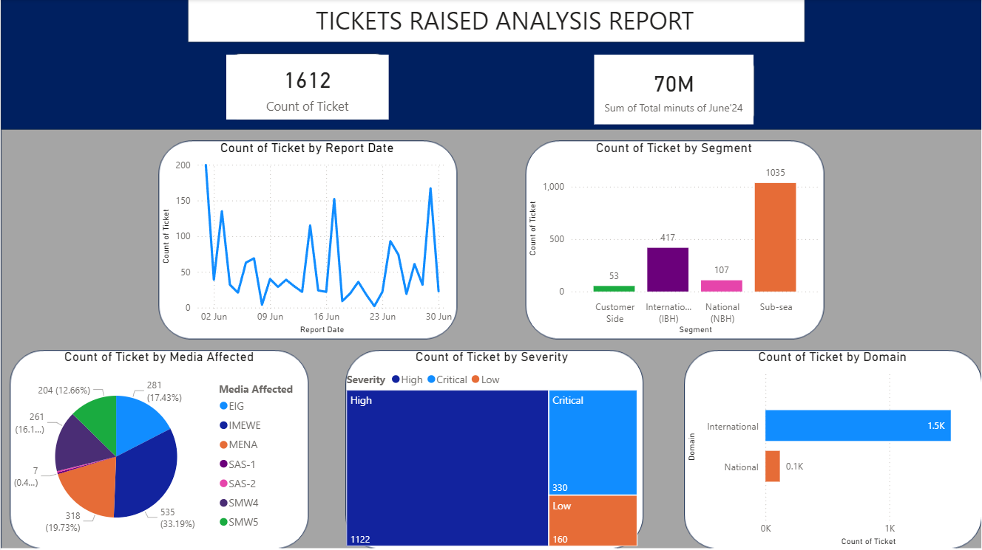
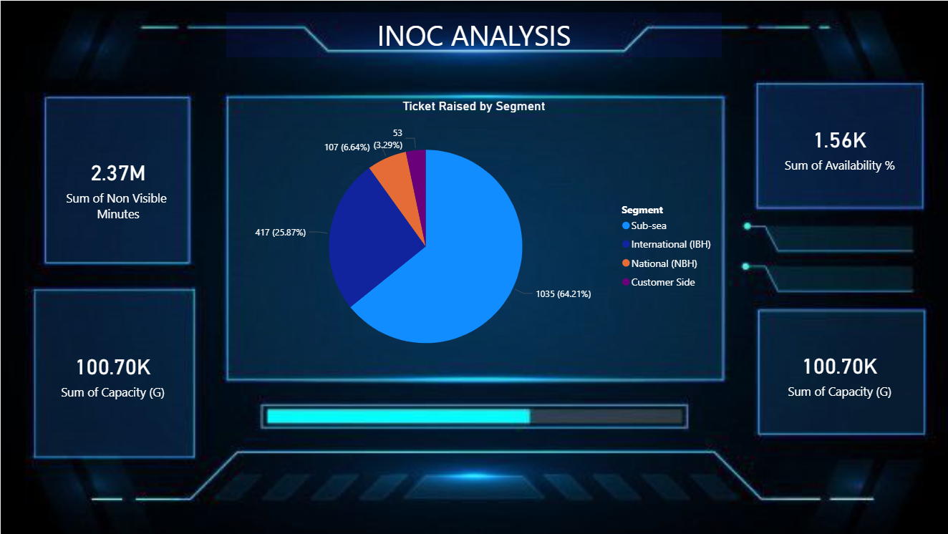

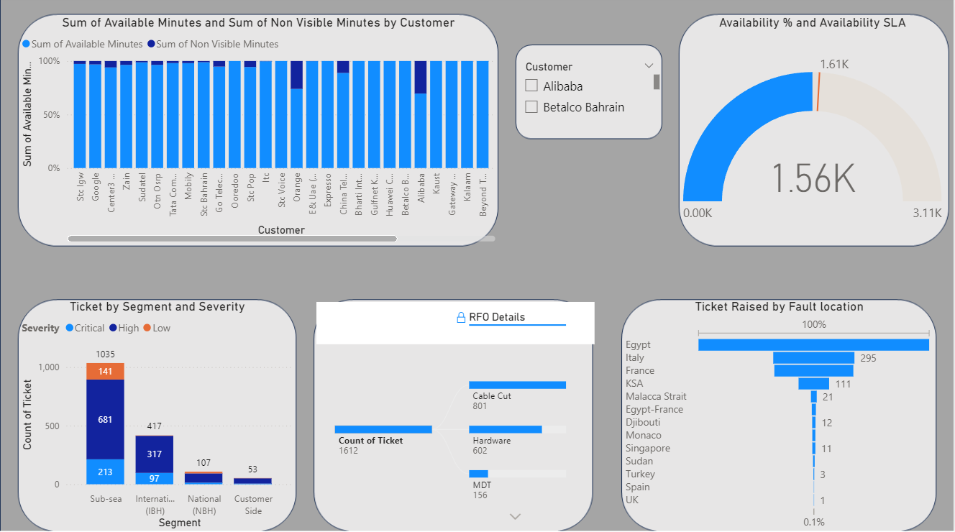
INOC ANALYSIS REPORT
- Ticket Raised by Segment:
This chart shows how many support tickets came from each segment.
Overall picture
Most tickets were raised by the Sub-sea segment, which clearly dominates the chart with 1,035 tickets, about two-thirds of all tickets (64.21%).​
The International (IBH) segment is next with 417 tickets, around one-quarter of the total (25.87%).​
Smaller segments
The National (NBH) segment raised 107 tickets, which is a small share at about 6.64%.​
Customer Side generated the fewest tickets, only 53, making up about 3.29% of the total.​
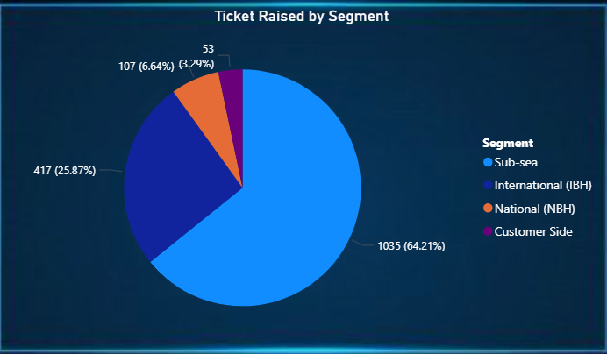

- Number of Tickets Changed Each Day in June:
This chart shows how the number of tickets changed each day in June.
Overall pattern
The count of tickets goes up and down a lot across the month, showing no steady trend.​
There are several sharp peaks where tickets suddenly rise, followed by drops back to low levels.​
High and low days
The highest spikes appear at the very start of the month, around the middle, and again near the end, where ticket counts are close to or above 150.​
Between these spikes there are many days with low ticket numbers, often below about 50, meaning those days had relatively few issues reported.​

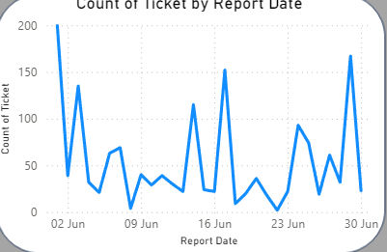

- Tickets were raised for each type of media:
This pie chart shows how many tickets were raised for each type of media.
Main observations
- SMW4 has the highest number of tickets at 535, which is about one-third of all tickets (33.19%).​
- MENA is next with 318 tickets, around one-fifth of the total (19.73%).​
Other media
- IMEWE accounts for 281 tickets (17.43%), while SMW5 has 261 tickets (about 16%).​
- SAS-2 has 204 tickets (12.66%), and SAS-1 is almost unaffected with only 7 tickets (about 0.4%).

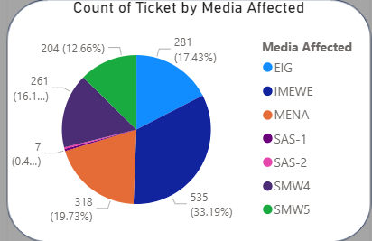

- KPI CARDS:
Capacity
- “Sum of Capacity (G) = 100.70K” means the total capacity across all items is about 100,700 units (for example, gigabytes or some other “G” unit, depending on your system).​
- This tells you the overall size or limit of what your system can handle.
Availability
- “Sum of Availability % = 1.56K” means you have added up availability percentages for many items, and the total is 1,560 percentage points.​
- To get an average availability, you would divide 1,560 by the number of items; for example, if there are 20 items, average availability is about 78%.
Non-visible minutes
- “Sum of Non Visible Minutes = 2.37M” means that, in total, items were not visible or not usable for about 2,370,000 minutes.​
- This is the downtime or impact time; a higher number means users could not see or use the service for more minutes overall.
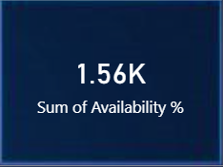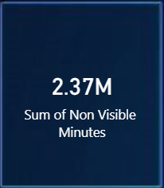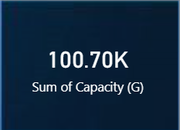

- Tickets There are for each Severity level:
This chart shows how many tickets there are for each severity level.​
Main point
Most of the tickets are High severity, with 1,122 tickets.​
Other severities
- There are 330 Critical tickets.​
- There are 160 Low tickets.​
What it means
The team has a large number of serious (High) tickets to handle, and fewer Critical and Low ones, so effort should mainly focus on clearing the High severity tickets first.

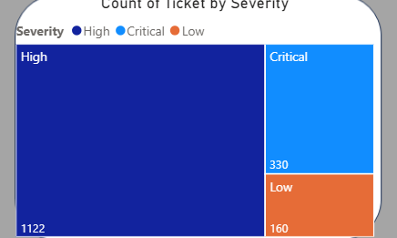

- Ticket counts differ across Segments:
This chart shows how ticket counts differ across segments.
Main point
Most tickets come from the Sub-sea segment, with 1,035 tickets.
Other segments
- International (IBH) has 417 tickets.
- National (NBH) has 107 tickets.
- Customer Side has 53 tickets.
What it means
The Sub-sea and International segments generate the highest ticket volumes, so they likely need the most attention and resources, while Customer Side and National have relatively few tickets.

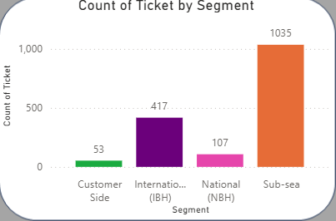

- Ticket counts between two Domains:
This chart compares ticket counts between two domains.
Main point
The International domain has a very high number of tickets, about 1.5K.
Other domain
The National domain has a very small number of tickets, about 0.1K (around 100).
What it means
Almost all tickets come from the International domain, so work and resources will mainly be needed there, while the National domain has relatively few issues.
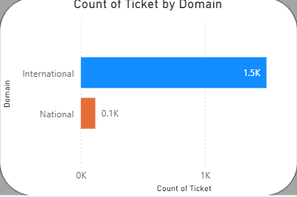

- Available Minutes & Non Visible Minutes:
This chart shows, for each customer, how many minutes were available and how many were “non-visible” (a smaller part of those minutes).
Main point
Almost all customers have a very high percentage of available minutes, shown by the tall light-blue bars close to 100%.
Non visible minutes
The dark-blue sections are small for most customers, meaning only a small portion of time is non-visible or affected.
A few customers have slightly larger dark-blue parts, which indicates more non-visible minutes and may need closer review.
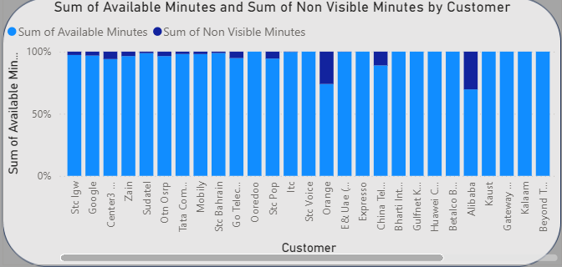

- Slicer:
This is a Customer slicer that lets you filter the visuals by selected customers.
- When you tick Alibaba, all charts will show data only for Alibaba.
- When you tick Betalco Bahrain, visuals will update to show only that customer’s data.
- You can select one or more customers at the same time, or clear the checkboxes to see all customers again.

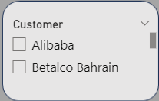

- Current availability compared with target SLA:
This gauge shows the current availability compared with the target SLA.
- The big number 1.56K is the current availability value.
- The thin line at 1.61K is the SLA target; anything at or above this is meeting the goal.
- Because 1.56K is slightly below 1.61K, availability is just under the SLA level and needs a small improvement to reach the target.

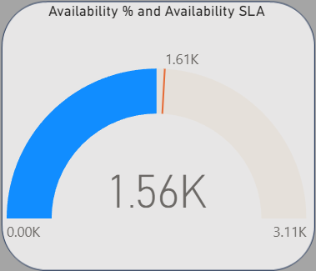

- Tickets each segment with Severity:
This chart shows how many tickets each segment has, broken down by severity.
Main point
The Sub-sea segment has the most tickets (1,035), with a large number of High (681), some Critical (213), and 141 Low tickets.
Other segments
- International (IBH) has 417 tickets: 317 High and 97 Critical, with very few or no Low.
- National (NBH) has 107 tickets, mostly High, and Customer Side has 53 tickets, all High.
What it means
Sub-sea and International (IBH) drive most of the ticket volume, especially High and Critical ones, so they need the most operational focus.

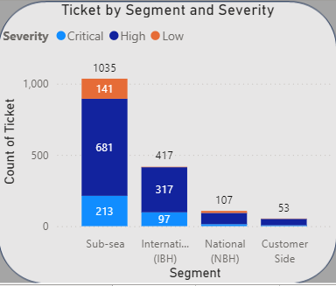
- RFO – Reason For Outage:
This visual shows the main reasons for outages (RFO – Reason For Outage) and how many tickets each reason has.
- In total there are 1,612 tickets.
- Cable Cut is the biggest cause with 801 tickets.
- Hardware issues are next with 602 tickets.
- MDT (likely Maintenance Down Time) accounts for 156 tickets.
Overall, most incidents are caused by cable cuts and hardware problems, so reducing these two would have the biggest impact.

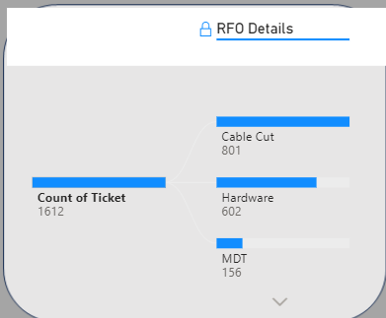

- Faults are happening, by Location:
This chart shows where faults are happening, by country or location.
- Egypt has by far the highest number of tickets, much more than any other location.
- Italy follows with 295 tickets, then France and KSA with smaller numbers, and other places like Malacca Strait, Djibouti, Monaco, Singapore, Sudan, Turkey, Spain, and the UK have very few tickets each.
Overall, most faults are raised from Egypt and, to a lesser extent, Italy, so these locations should be priority areas for investigation and improvement.

